Task 1

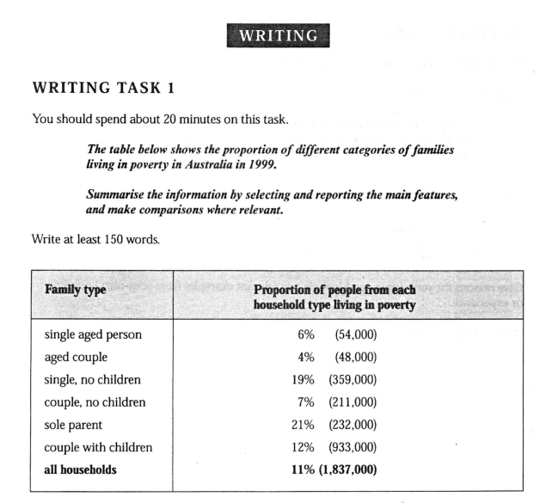

Analysis of Families Type in Poverty

The proportion of all household types living in poverty is 11%. It is a serious problem. What is worse is that nearly one-fifth of sole parents are living in poverty. Many children might not be well raised because their parents could not earn enough money to support their families. Let’s see the families of couples with children; the percentage is 12% and it is higher than the average rate, but the proportion is 7% for couples without children. That means raising children costs much money and is quite difficult for couples, let alone a sole parent.

The weird thing is that 19% of single persons also live in poverty so it is a right choice for them to choose to be unmarried, or their children won’t have access to nutritious meals.

There is a small proportion among aged and single aged couples. They are old and should live a happy retired life.

**improved by Grammarly**

The poverty rate among all household types is 11%, which is a severe problem. However, the situation is even worse for sole parents, with nearly one-fifth of them living in poverty. This can lead to a lack of proper upbringing for their children due to financial constraints. When it comes to couples with children, the poverty rate is 12%, which is higher than the average rate, while it is only 7% for couples without children. This indicates that raising children can be quite challenging and expensive for couples, especially for sole parents.

Interestingly, 19% of single individuals are also living in poverty, which makes it a wise choice for them to remain unmarried, as the lack of financial resources might prevent their children from having access to nutritious meals.

On the other hand, the poverty rate is relatively low for the elderly and single-aged couples, who should be able to enjoy a happy and comfortable retired life.